Servo Creel Development

Owen Lu

Electroimpact Inc.

owenl@electroimpact.com

*Abstract*—This document summarizes the overall process of developing the servo tension control system (STCS) on the new generation Electroimpact AFP H16 heads. Overall, the system was developed to increase both reliability and performance simultaneously, and a fully functional H16 prototype head has since demonstrated these feats by laying up on a Boeing spar tool.

# Introduction

A large portion of the research and development done at Electroimpact Inc. done until recent times was done as a direct response to a problem that a customer has brought up. From process experience operating the machines, optimizations are often made between generations of AFP heads as well as within the same generation if the hardware is not functioning as well as expected. This approach while time efficient becomes very costly as it is a rudimentary form of R&D conducted on-site requiring expensive engineering hours, expedited mechanical parts and often in the absence of high bandwidth measurement devices found in a lab. The solutions pertaining to tension problems often require significant process experience to implement correctly and also require knowledge debugging pneumatic systems as well as tuning a highly non-linear control loop without system identification.

The main principle behind developing the servo creel system was to improve performance while maintaining or exceeding current reliability and reduce the risk of integration. Naturally, introducing a completely new electromechanical system to the current machines carries a large risk. Thus, a ground-up approach, building simulations predict performance and to identify suitable systems combined with an emphasis on experimental testing was taken. Every subsystem that composes the STCS was tested both independently and in combination with relevant parts in worst case scenario operation. Furthermore, a fully functional prototype head was created using the same subsystems and has been demonstrated to be working.

After the initial proof of concept was deemed successful a single lane prototype connected to a robot was done in order to verify the real world performance of the tensioning system. Further test benches were created and extensive testing was done on the sensors, power delivery, and mechanical assembly to ensure that in isolation and in combination the major components exhibited robust performance. Finally, a full prototype AFP head was created in order to nail down the exact architecture of the machine before delivery to the customer.

# Specifications

This project has been undertaken in order to remedy tow slack issues in the 777X project. During a large number of high acceleration cycles and high-speed operation, slack would likely occur. Using servo drives instead of pneumatic brakes, high bandwidth control of the dancer position can be achieved with no tension loss. Subsequently, the tension in the tow can also be controlled to a far greater degree of accuracy and can be predicted to within 3% given a velocity profile.

The following processes are the strictest requirements placed on the servo tensioning system during operation.

1. The system is turned on with some nominal tension in the tow
2. The reference is set and the servo controls the dancer to the reference position via velocity input to the motor
3. After this, one of two scenarios will be realized
   1. Case 1: A step velocity input at the feed is activated at 3000in/min
   2. Case 2: A ramp velocity input at the feed is activated at 0.5G up to 4000in/min

These requirements would result in a material add speed increase of 87.5% and a top speed increase of 11.1%. More importantly, the dancer tension is predictable based on control constants and in the presence of functioning sensors will never result in tension loss, or sudden tension spikes even in the presence of an unlimited number of acceleration cycles.

# Controller Design and Inertia

Initially, the tensioning problem was separated into two problems to be solved in sequence. The first was to develop a simple and effective control structure for reducing the peak torque required during the payout process. A numerical simulation was created to understand the advantages of different control structures and the effect on torque consumption which was used to narrow down the motors considered. This allowed resources to focus on the advantages of different systems in terms of implementation as opposed to finding a motor that had optimal performance and form factor for the application.

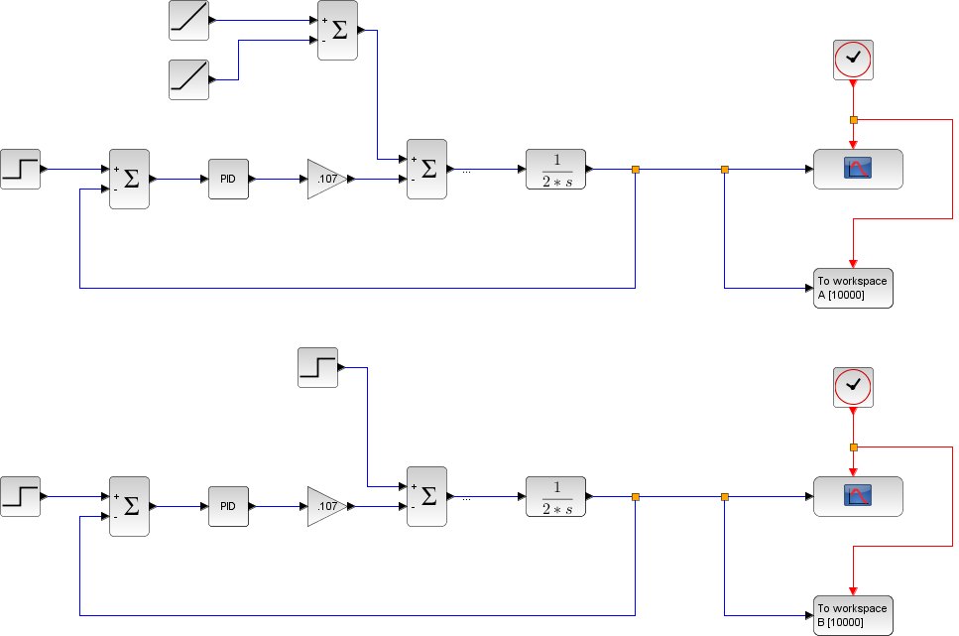

Figure - Initial simplified control structure for motor sizing/controller design

Once this structure was identified, a model estimate of inertia was combined with experimental data in order to quickly identify suitable motors for the process. Weighing carbon spools and creating solid models with similar geometry and uniform density was used to estimate the inertia of the spool which is the main inertial element in the system. Interpolation methods were then used to estimate the inertia for any radius that lies within the range of modeled values.

A simple model of inertia was made and fit to the data for interpolation.

|  |  |  |
| --- | --- | --- |
|  |  | () |

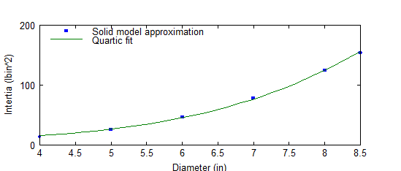

Figure - Example of a curve fit to estimate load inertia

After the inertia estimate, frequency domain identification was used to get a better estimate of effective inertias present in the system.

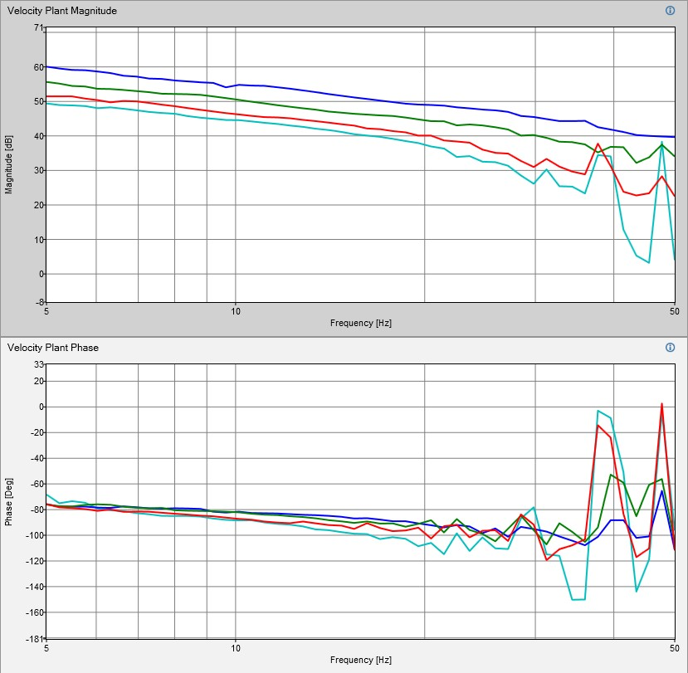

Figure - Example of open loop velocity plants with different sized spools.

The motor requirements emphasized a compact form factor, and the ability to independently operate from the main PLC and CNC for a decentralized control structure. During the whole process, motor selection in terms of performance specifications was a straightforward procedure. However, the decision of the best servo system was determined by ease of integration with respect to our current PLC system to minimize risk.

# Diameter Sensor Testing

Central to the problem of creating a reliable STCS was the sensor selection. The two main elements are the linear displacement and diameter sensors. The linear sensors used were the same as the ones used in the production

Since STCS research is being conducted simultaneously, the same test rig was used, a solid model representation is shown in Figure 4.

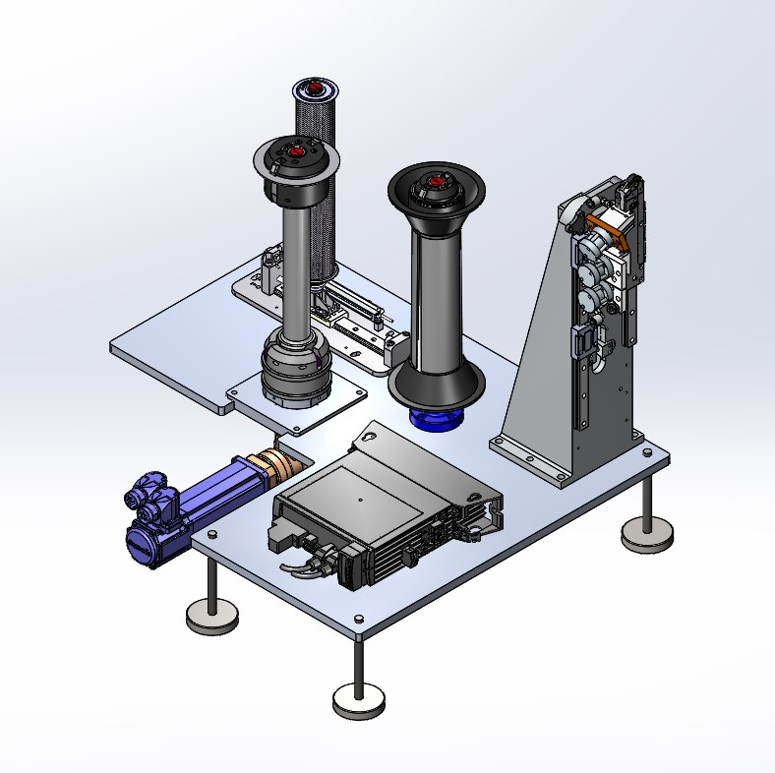

Figure - Solid model representation of the test apparatus

The reason it is mounted to the test rig is so that the servo can rotate and the angular position of the output shaft can be recorded simultaneously with the diameter measurements.

|  |  |  |
| --- | --- | --- |
| Sensor | 95% CI (mm) | Min/Max (mm) |
| BOD000N | (94.4, 96.3) | (79.7, 105.0) |
| ODSL8 | (95.0, 95.7) | ( 87.4, 99.2) |
| S004J | (95.2, 95.52) | (93.9, 96.5) |

All sensors agree with the caliper measurements within their 95% confidence intervals and are suitable for the task. However, a construction of polar plots given time domain angular position and radius measurements allows us to see the clear winner instantly. Following are the polar constructions of the time domain diameter data in Figure 5.

|  |
| --- |
| C:\Users\owenl\Documents\2TOW\TESTS\SPOOL_ULTRA.bmp |
| C:\Users\owenl\Documents\2TOW\TESTS\SPOOL_LASER_2.bmp |
| C:\Users\owenl\Documents\2TOW\TESTS\SPOOL_LASER.bmp |

Figure - Polar construction of spool; Ultrasonic (top), Leuze laser (middle), Balluff laser (bottom)

# Simulation and Verification

After the initial selection of suitable hardware was complete, verification of the mathematical models was conducted on the test bench. Testing consisted of paying out material with a known velocity profile and measuring the dancer displacement over time. Afterward, the dancer response was compared with simulation models and shown to agree within 3%. Figure 6 shows the dancer response curve compared with the theoretical response. The STCS generates dancer responses which are more regular and predictable than the typical pneumatic response shown in Figure 7. Furthermore, it is currently not possible to predict dancer behavior based on tuning constants in the pneumatic creel, eliminating the possibility for process error checking using the curves.

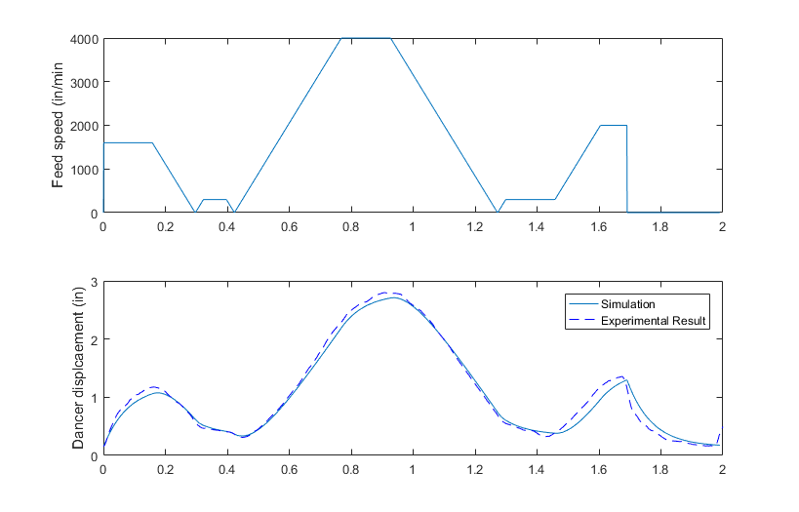

Figure - Feed velocity profile (top); Dancer displacement compared with the experimental result (bottom)

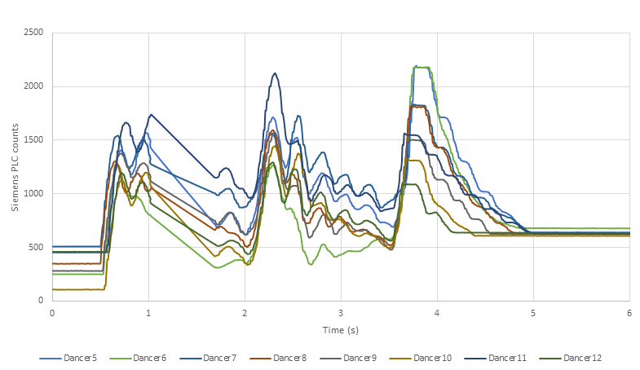

Figure - Typical pneumatic dancer performance during spar layup

# Electrical Testing

In order to power the STCS, the power system was tested for the ability to supply power during the acceleration as well as the ability to absorb energy during a deceleration/regeneration phase. A custom power delivery system was built in order to protect sensitive control electronics inside the motor from bus over-voltage scenarios due to regeneration.

Aggressive acceleration cycles simulating regeneration situations worse than ones observed in practice were run for extensive periods in order to verify that the protection circuits were operational. We observed voltage spikes that were far lower than the rated voltage of the electronics of the motor.

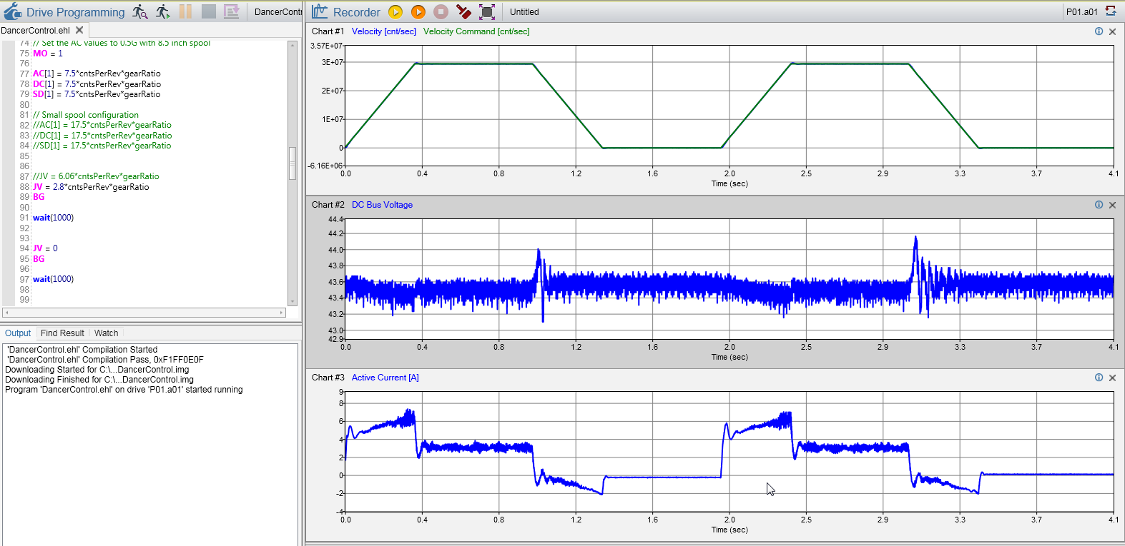

Figure - Acceleration cycle (top); DC Bus voltage (middle), Winding current (bottom)

# Robot Testing

After the hardware was tested, the test bench was moved to a back plate with an ATI tool changer. A PLC and the pneumatic system required to perform simple add, cut and clamp operations on a single lane was added to the system to allow a better simulation of the process. These parts were harvested off an older test bench in the interest of time since the STCS was the system to be tested.

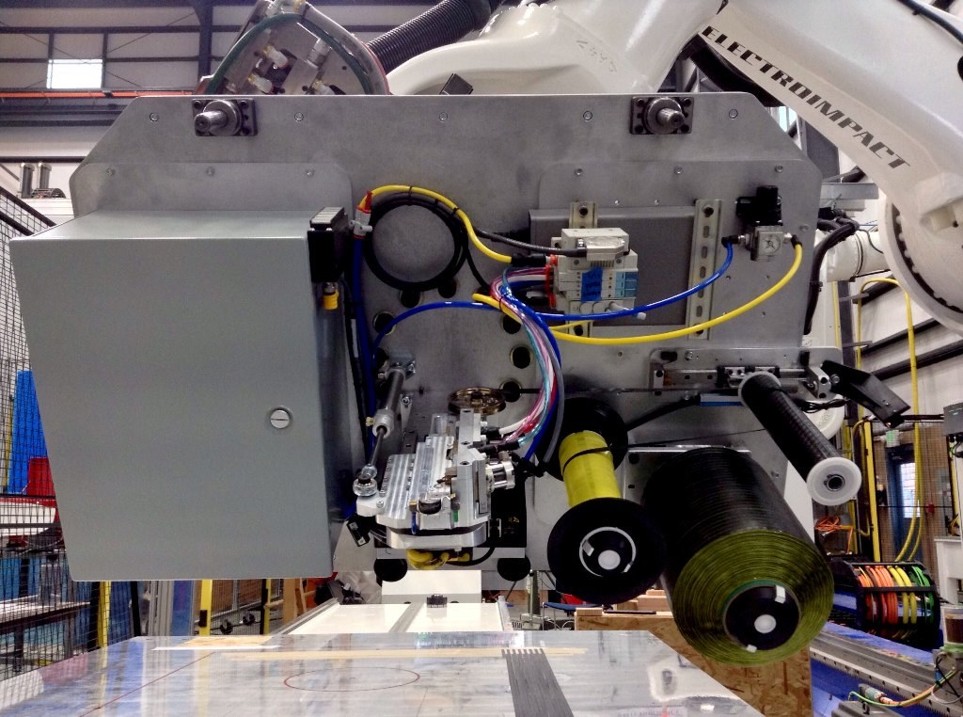

Figure - Test bench with robot tool changer used to verify STCS performance

After approximately one week of testing, no STCS related failures were observed. In Figure 10 the robot laying tow on a flat tool is shown. The dancer behavior observed on the test bench was exactly replicated on the robot prototype and is shown in Figure 11.

This successful test set the precedence for further development and the creation of an Electroimpact research head design around the STCS.

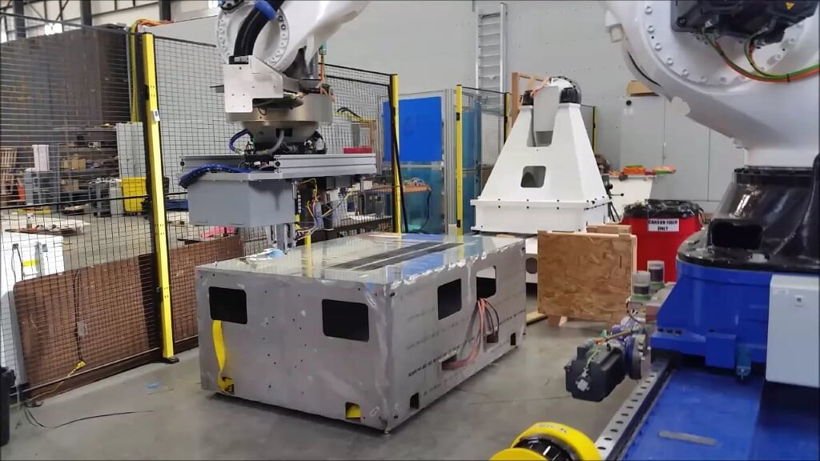

Figure - Robot prototype laying up material on tape

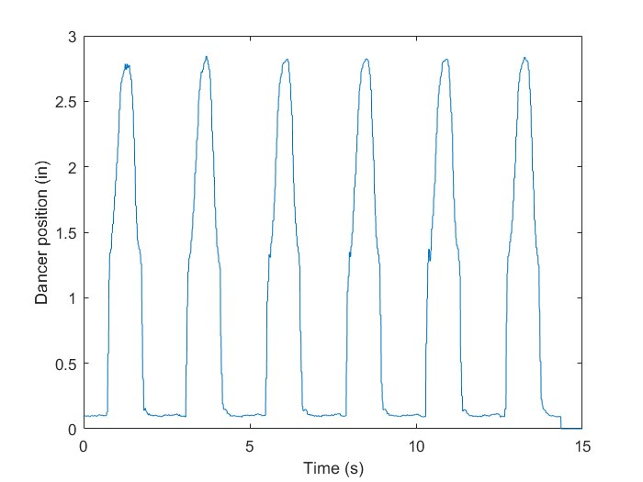

Figure - Dancer performance during high speed/high acceleration cycles

# H16EXP Prototype

A Half-Inch 16 Lane Experimental prototype (H16EXP) was created to verify and demonstrate the reliability of the STCS in real-world applications. High-level control from the PLC to individual motors is passed through a Profinet daisy chain for operation, shown in Figure 12.

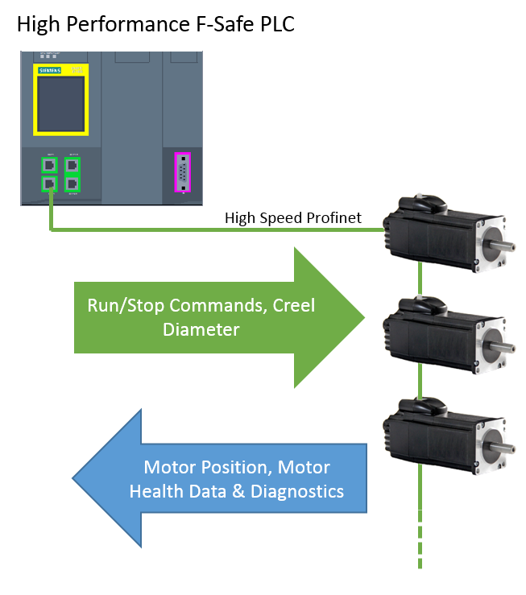

Figure - Overall communication architecture

Each tension system on individual lanes is completely controlled by signals fed back to the motor controller. The diameter signal which is not time critical is filtered by the PLC in order to guarantee signal quality and then passed over Profinet to the motor. A diagram showing the main signals and mechanical components per lane are shown in Figure 13. The full H16EXP head is shown in Figure 14.

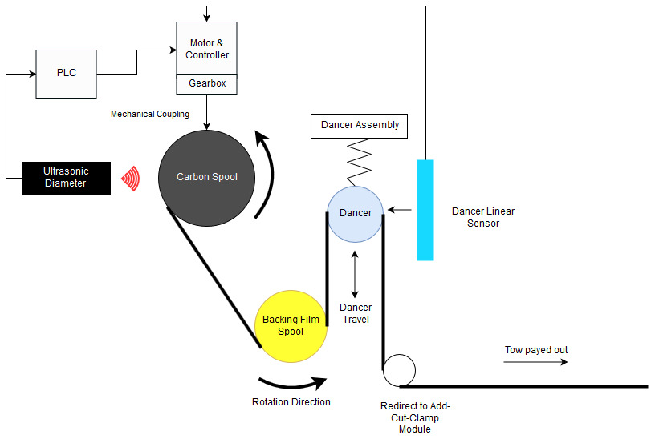

Figure – Critical single lane components and signal diagram

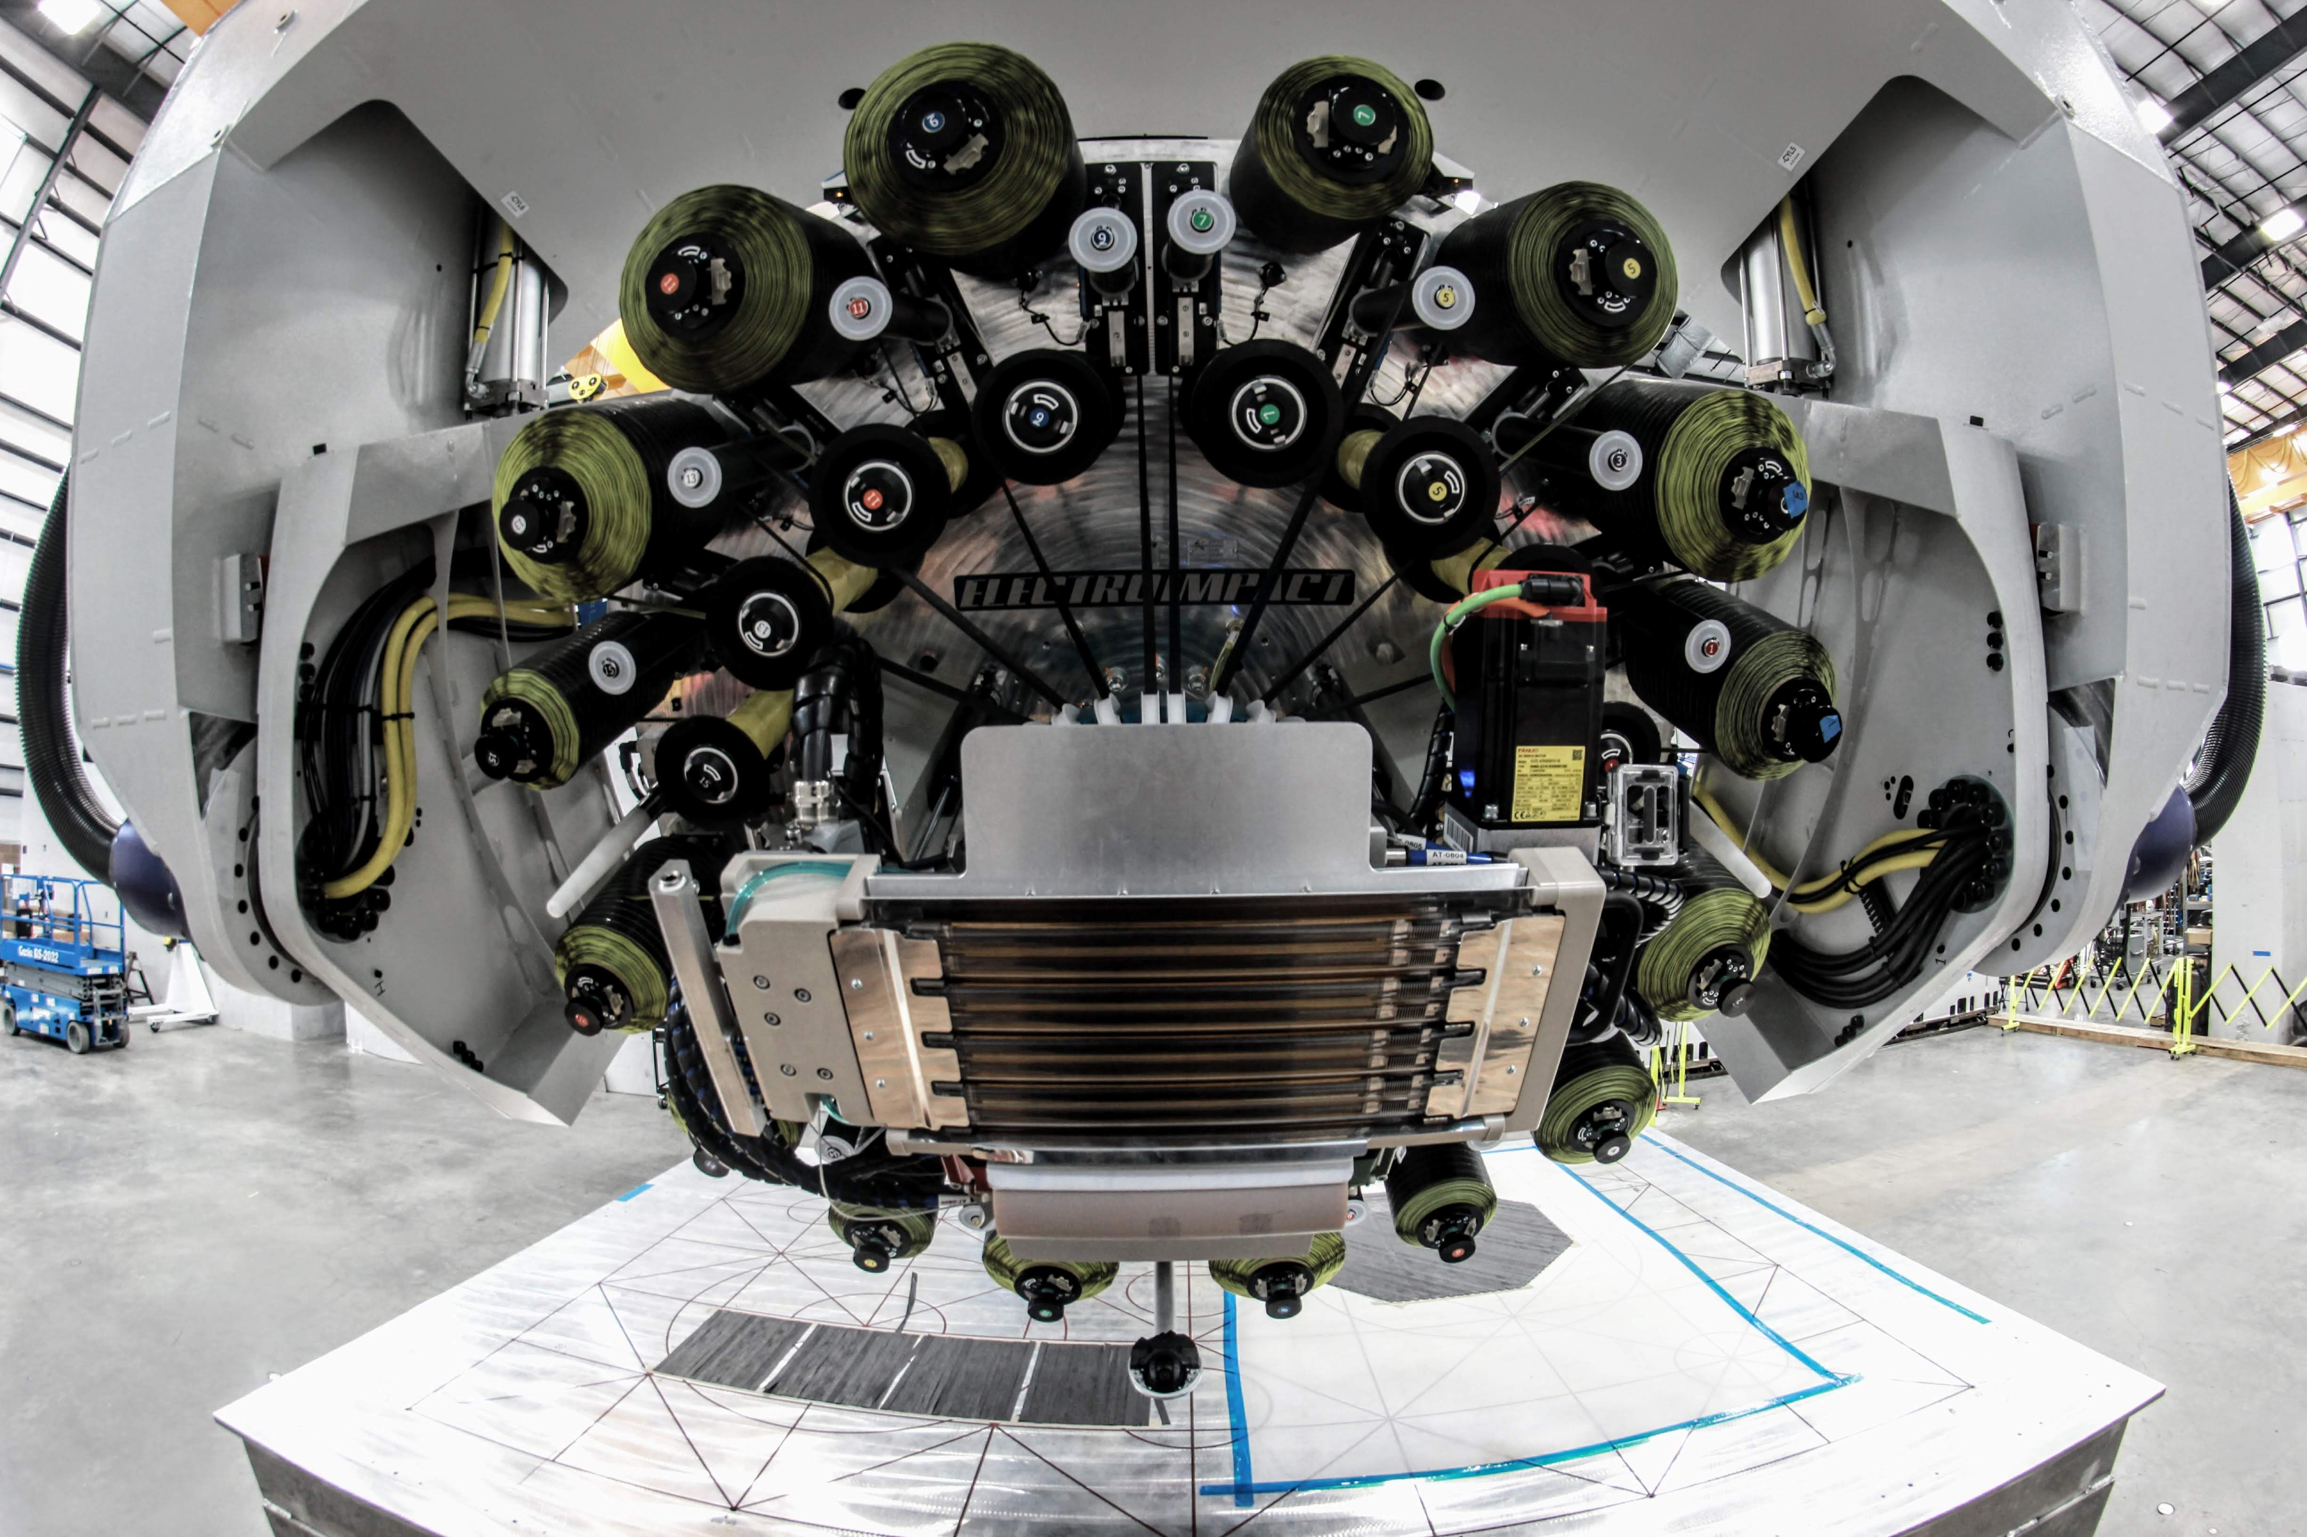

Figure – Front view of the H16EXP head

Minor modifications to the electrical and mechanical system were made to improve the full 16 lane design. After tuning of the system, the dancer performance still maintained its repeatable and reliable behavior and has now been shown increase reliability dramatically whilst maintaining higher performance. This is discussed in more detail in Section IX.

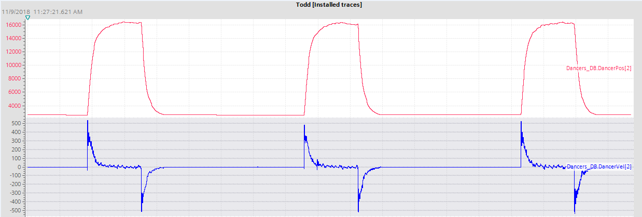

Figure – H16EXP dancer trace (top); H16EXP dancer velocity trace (bottom)

As shown on the test bench, the predictable behavior allows for error checking in process one characterization is complete. An example layup done on the H16EXP system is shown below in Figure 15.

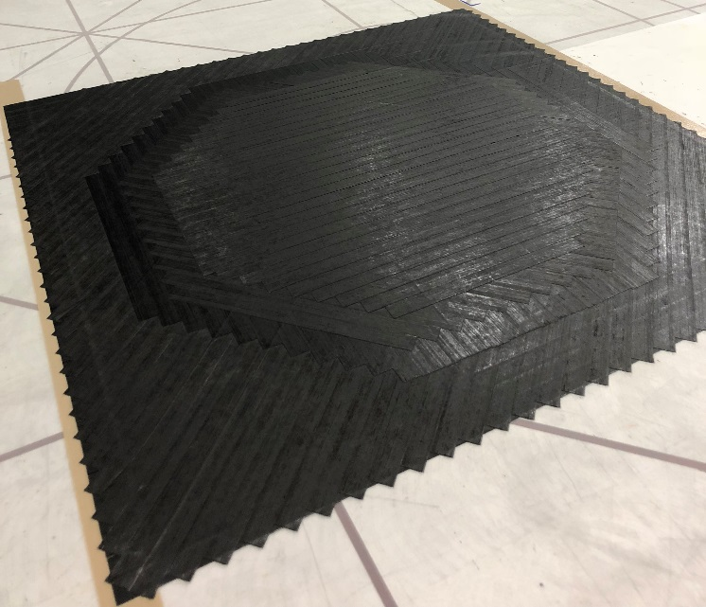

Figure - Example H16EXP layup

# Overall Mean Strips Before Failure (MSBF)

A critical metric for measuring the reliability of the system is the mean number of strips before failure (MSBF). For clarity, one strip is counted as 1 lane paying out during a course. That is during a full course, 16 strips are placed on the part. Currently, the traditional Electroimpact pneumatic creel head has an MSBF of approximately 3,100 on zero degree plies. However, on the H16 prototype head, we have successfully placed a full zero ply on the spar tool which consists of 11,400 strips of tow without failure. The servo creel head has not been observed to fail due to tension issues even at the increased performance and thus, the goal of increasing reliability and speed simultaneously has been achieved with the servo tensioning system.